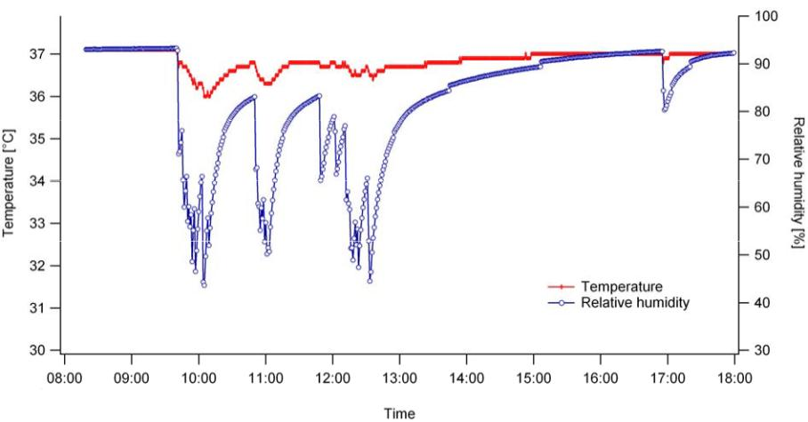

Application Note 12
Avoiding Evaporation
0. Introduction
Depending on incubation conditions, small volumes of cell culture medium may
evaporate quickly, especially during long-term experiments. Furthermore, all cell
culture incubators need a fairly long time to recover humidity, particularly after door
openings. While temperature and CO2 is recovered within minutes, full humidity
recovery can take hours.
The above graph shows the temperature and humidity inside a CO2 incubator over a 10 hour
day, during and after briefly opening the door. The graph shows only minor differences in
temperature over the day, i.e., between 36°C and 37°C. However, it shows significant
differences in relative humidity over the day, i.e., between less than 50 % and the steady state
of 93 %. An important fact to note is that this incubator had not been opened all afternoon,
except briefly just before 5 o’clock.
Therefore, for controlling and decreasing evaporation we recommend the following
techniques:
1. A Petri dish with wet tissues (Page 2)
2. An Olaf humidifying chamber (Page 2)
3. Parafilm (Page 3)
4. Silicon oil (Page 3)
Application Note 12
© ibidi GmbH, Version 2.0, Elias Horn, August 25, 2011

Page 1 of 3

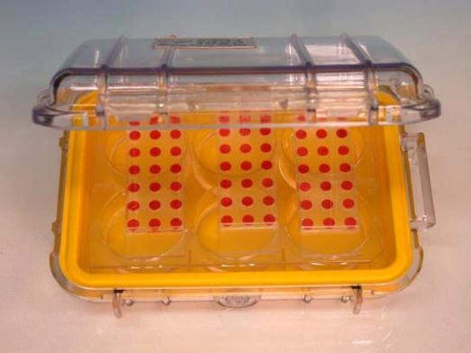
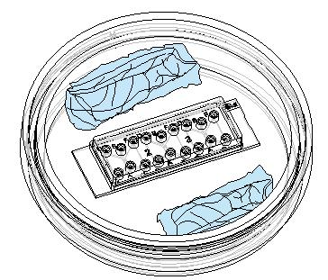
Application Note 12
1. A Petri Dish with Wet Tissues
A simple humidifying chamber can be made using a
10 cm Petri dish with wet tissues inside (as shown
on the right). Use EDTA (Ethylene-Diamine-
Tetraacetic Acid) stabilized water and sterile tissues
for longer incubation periods. One advantage of this
technique is that it allows access with low
resolution microscopy to check, for example, the
adherence of cells. This technique is recommended
for use inside cell culture incubators.
2. Olaf Humidifying Chamber
The Olaf Humidifying Chamber (Cat No. 80008) prevents problems caused by
evaporation, especially during long term assays. Olaf is a humidifying chamber that
can be completely sealed, which prevents loss of humidity while inside an incubator.
The Olaf chamber can be sterilized with a mixture of 70% ethanol and water, and is
recommended for use inside cell culture incubators.
Procedure:
• Fill a standard 6 well plate with sterile water (i.e., 4 ml per well) and place the
plate into an Olaf chamber. Use EDTA stabilized water for longer term
experiments.
• Put a μ-Slide on top of the 6 well plate, close the Olaf chamber and place the
chamber into an incubator.
An Olaf Chamber with aμ-Slide 18 well inside. A water-filled 6 well plate provides humidity.
Another option is to place a μ-Slide Click Rack (Cat No. 80007) onto the water-filled
plate. This option allows convenient handling of up to 4 μ-Slides in parallel.
Please note, however, that the μ-Slide 18 well is not compatible with the μ-Slide
Click Rack. In this instance we recommend placing a μ-Slide 18 well directly on top
of the 6 well plate.
Application Note 12
© ibidi GmbH, Version 2.0, Elias Horn, August 25, 2011

Page 2 of 3

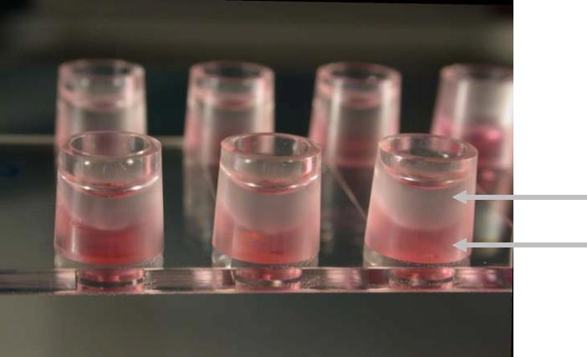
Application Note 12
3. Parafilm
Placing small strips of Parafilm (produced by the Pechiney Plastic Packaging
Company) onto the reservoirs of the slides will prevent the effects of evaporation.
Just fill the slide as recommended and then stretch the Parafilm on top until it fits
tightly.
The Parafilm technique is recommended for use with stage top incubators and with
non-humidified incubated microscopes.
4. Silicon Oil
To prevent evaporation effects one can overlay the cell culture medium with Silicon
Oil AR 200 (available from Fluka, Sigma-Aldrich). Silicon oil is gas permeable and non-
toxic. Please don’t use mineral oil as this is harmful to the μ-Slides.
Procedure:
• Autoclave the silicone oil.
• Equilibrate oil and cell medium inside the incubator overnight. This step helps
in avoiding the formation of air bubbles and pre-warms all solutions to 37°C.
• Fill your slide with cells and medium.
• Overlay the medium’s surface with an appropriate amount of silicon oil. Do
not drip the oil directly onto the surface, rather let it run down the edges by
pressing the pipette tip onto the upper side of the reservoir. For example,
when using the μ-Slide VI , fill each reservoir with 30 μl cell-free medium
0.4
and 30 μl silicone oil.
The silicon oil technique is recommended for use with stage top incubators and
when imaging for several hours using non-humidified incubated microscopes.
Silicon oil
Cell medium
μ-Slide VI
0.4
with silicon oil inside the reservoirs, which is used to decrease evaporation in non-
humid environments, e.g., on the microscope.
Application Note 12
© ibidi GmbH, Version 2.0, Elias Horn, August 25, 2011

Page 3 of 3

